3-Tier Architecture Project

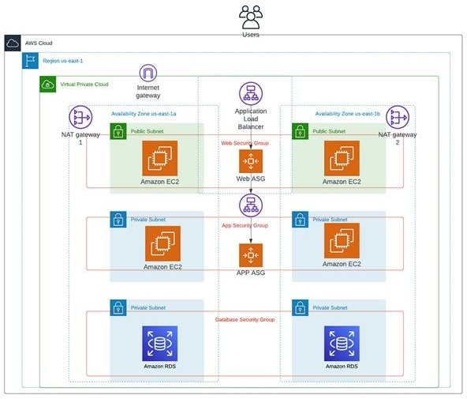

CREATE VPC:

IPV4 CIDR: 30.0.0.0/16

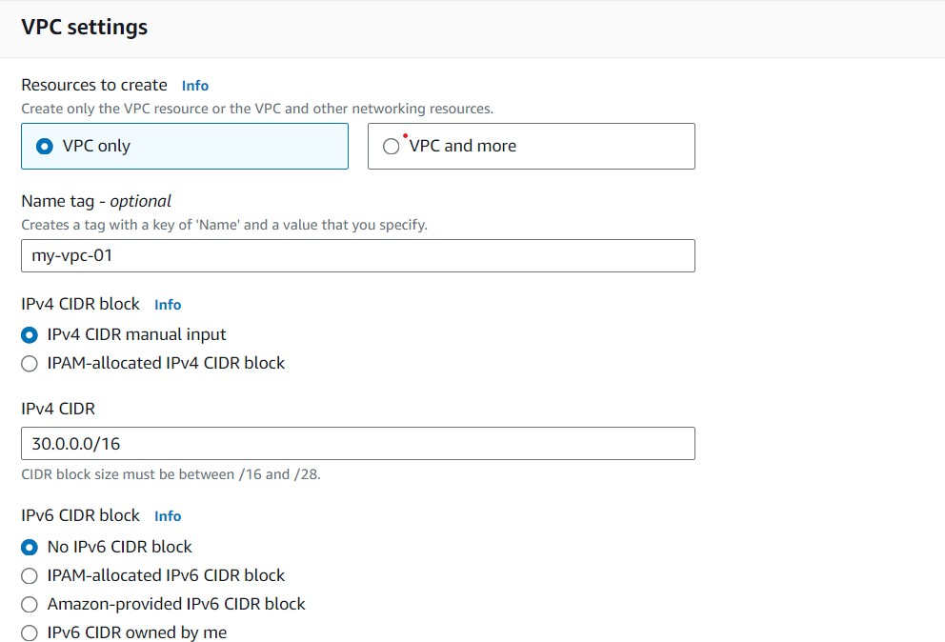



CREATE SUBNET: 1

NAME: public-subnet-1 IPV4: 30.0.0.0/24

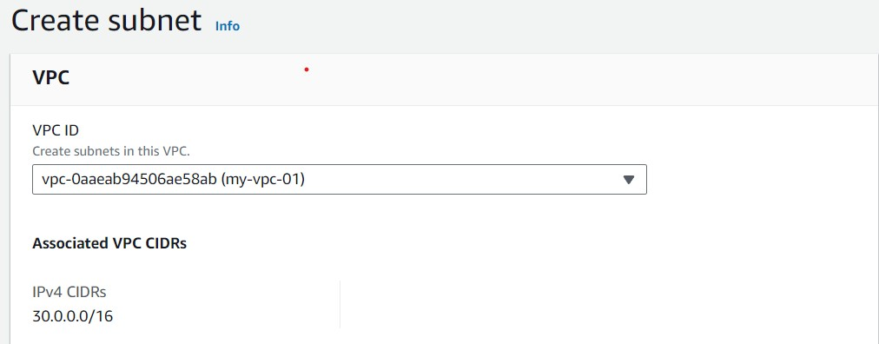

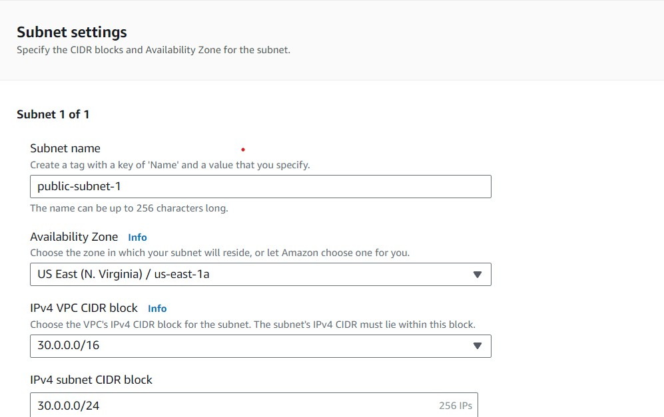

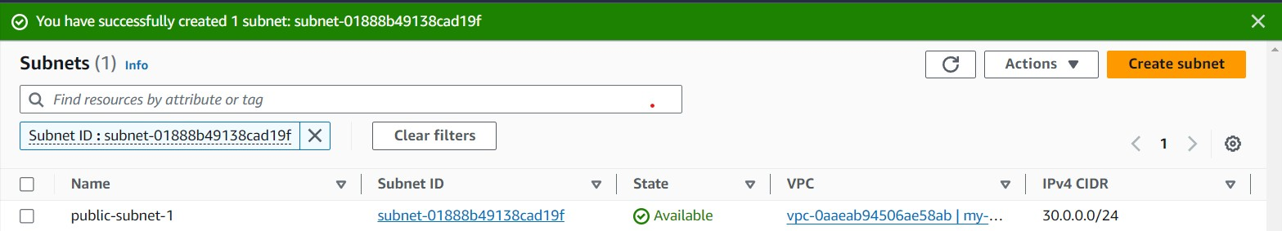

CREATE SUBNET: 2

NAME: publice-subnet-2 IPV4: 30.0.30.0/24

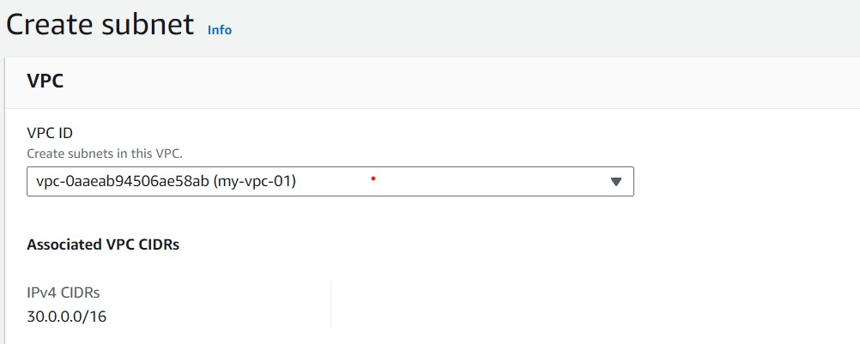

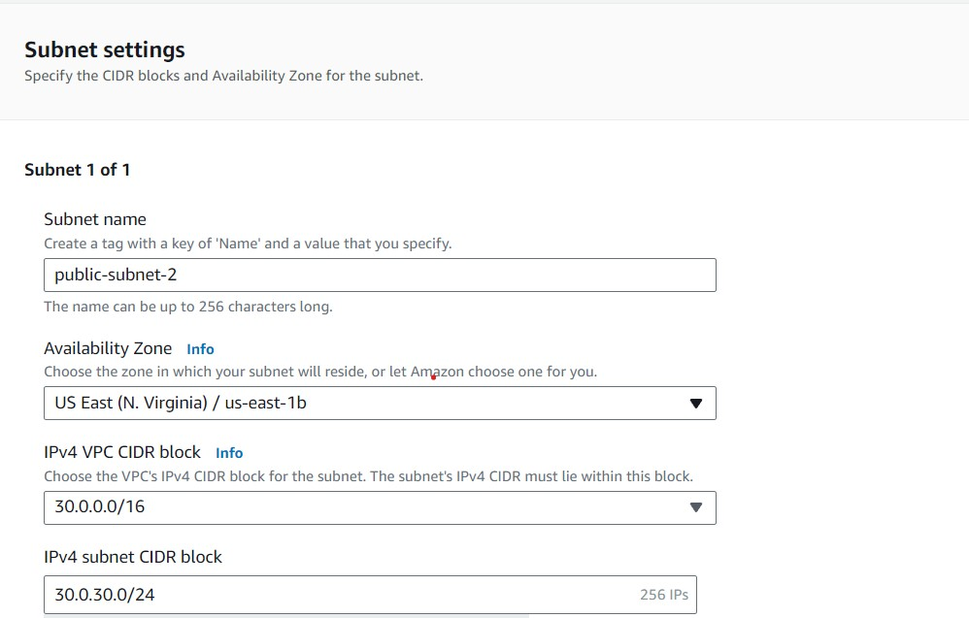

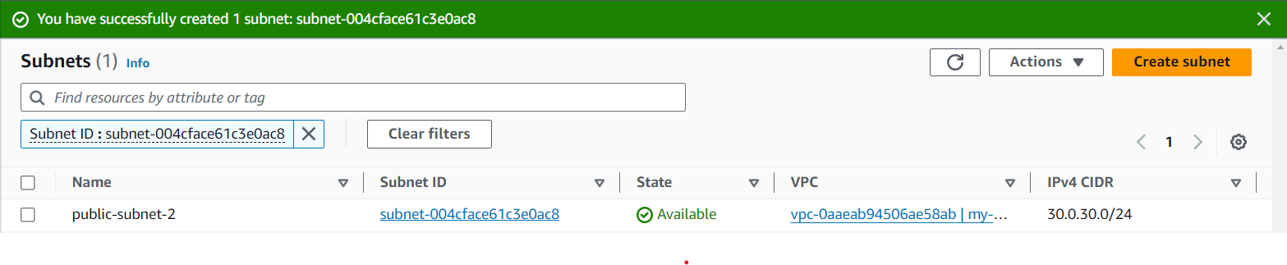

CREATE SUBNET: 03

NAME: private-subnet-1 IPV4: 30.0.31.0/24

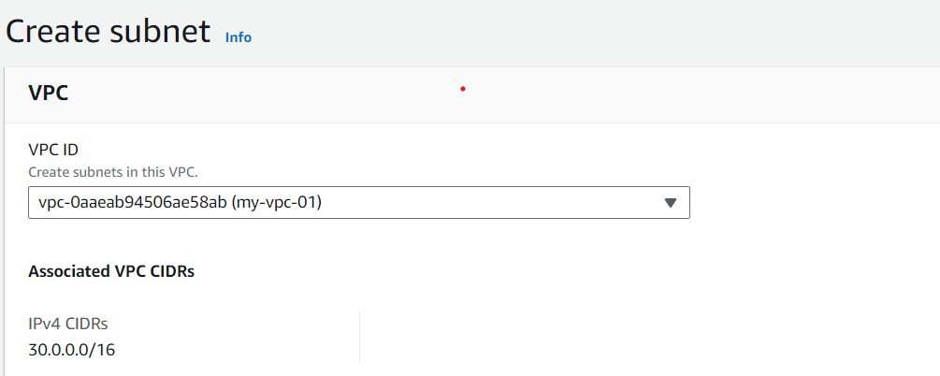

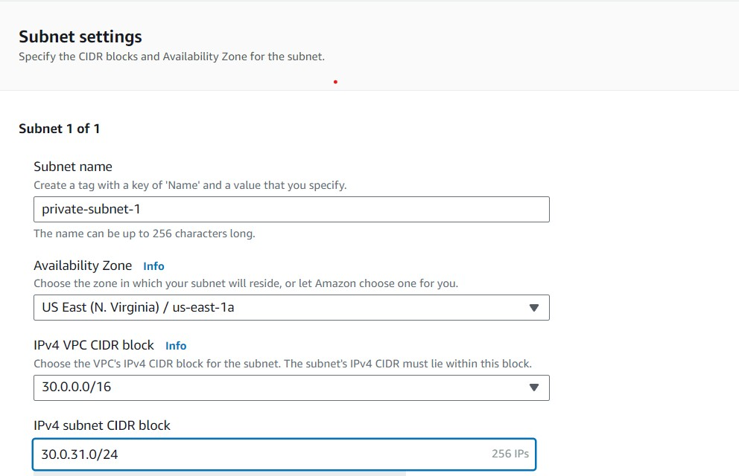

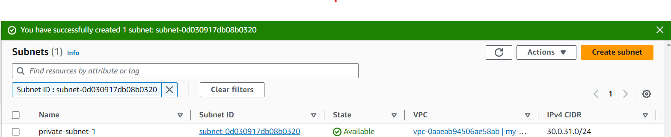

CREATE SUBNET: 04

NAME: private-subnet-2 IPV4: 30.0.32.0/24

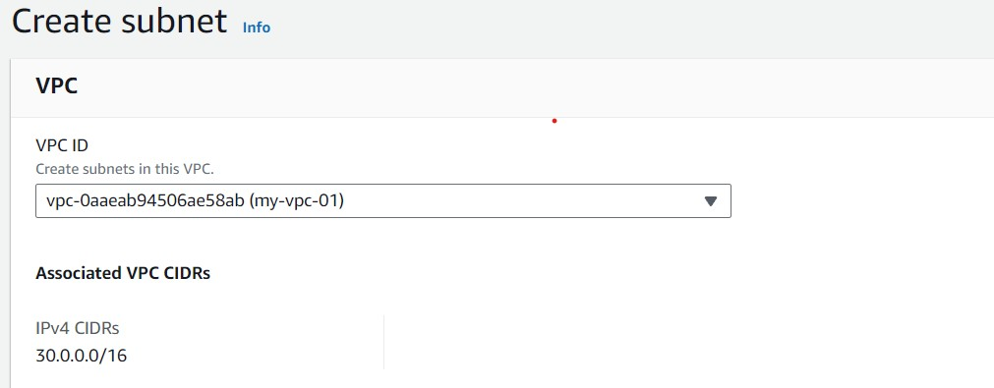

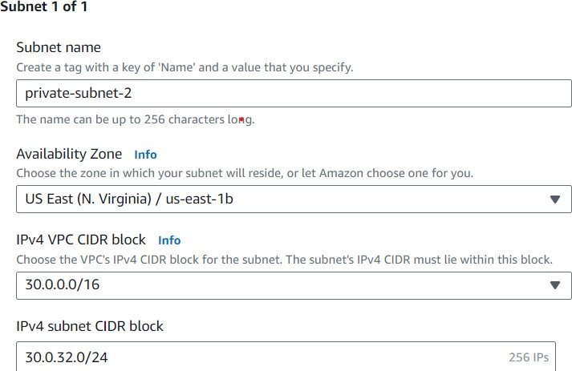

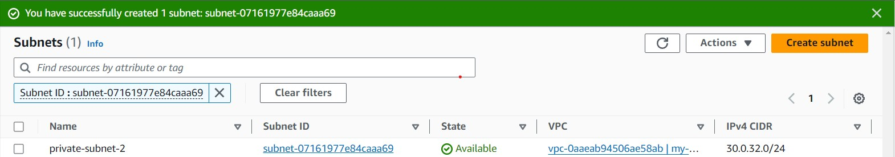

CREATE SUBNET: 05

NAME: private-subnet-RDS1 IPV4: 30.0.33.0/24

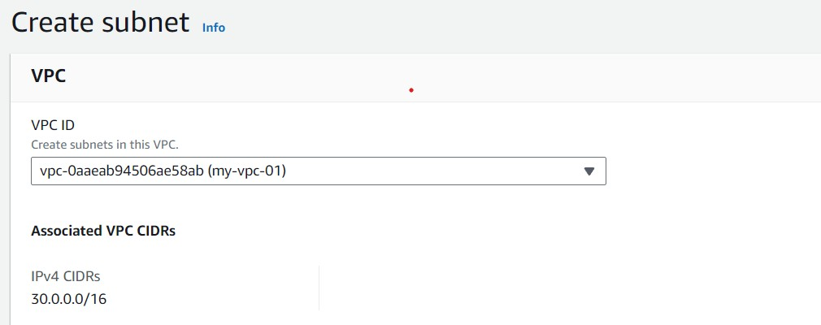

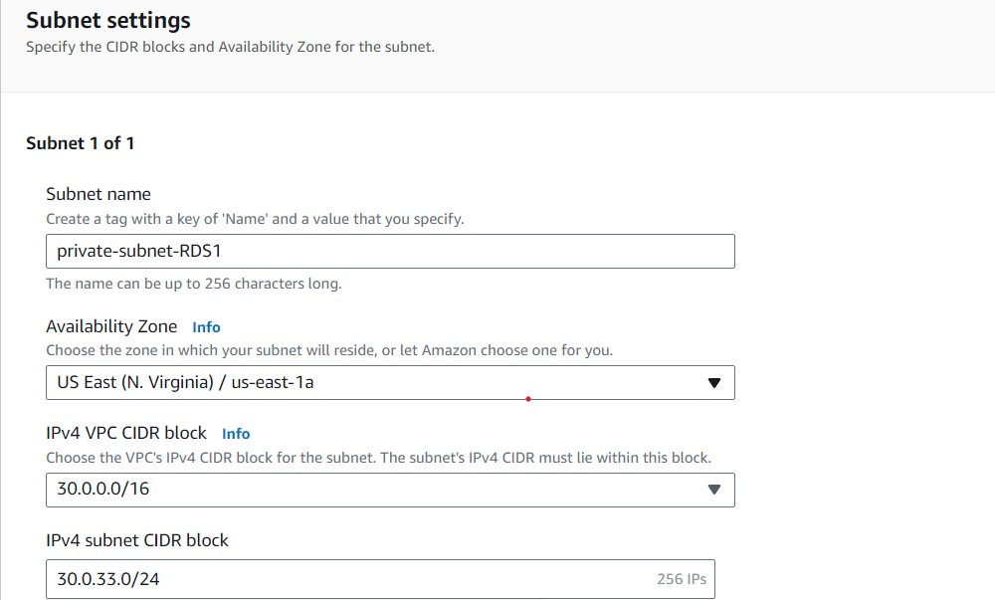

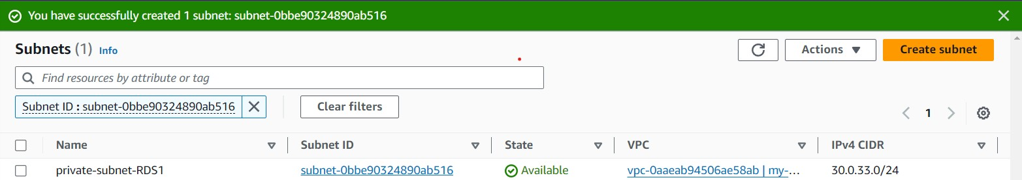

CREATE SUBNET: 06

NAME: private-subnet-RDS2 IPV4:30.0.34.0/24

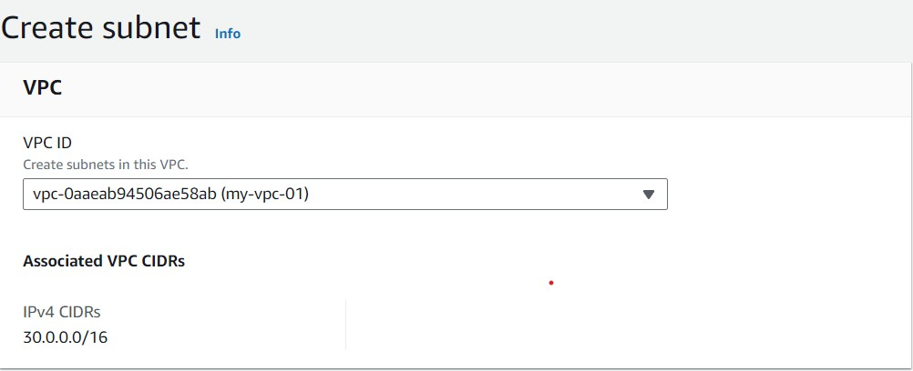

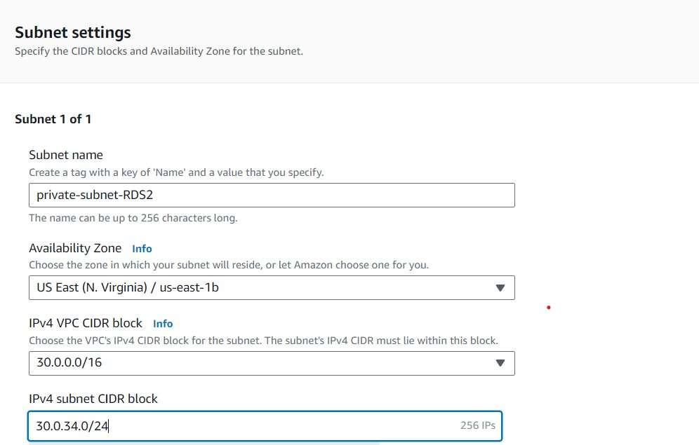

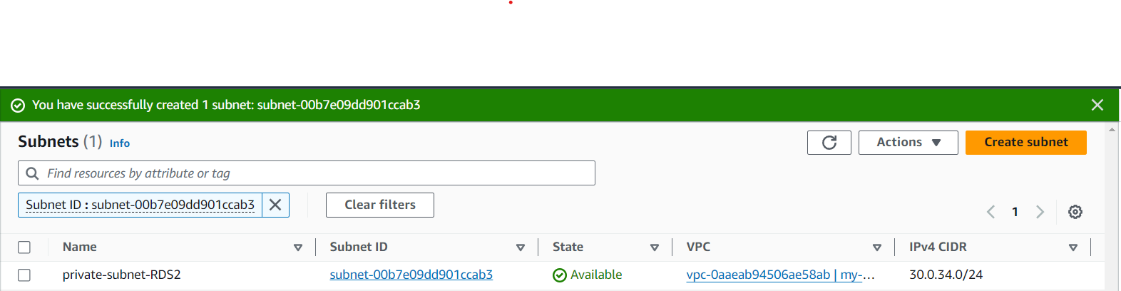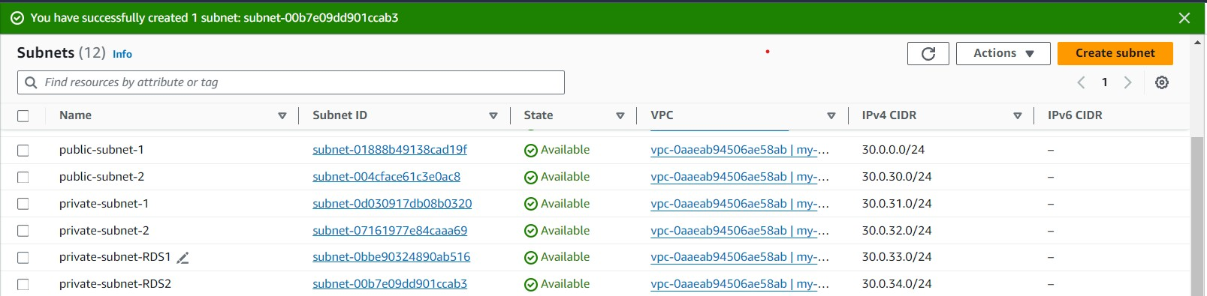

CREATE INTERNET GATEWAY AND ATTACH TO VPC: NAME: IGW-1

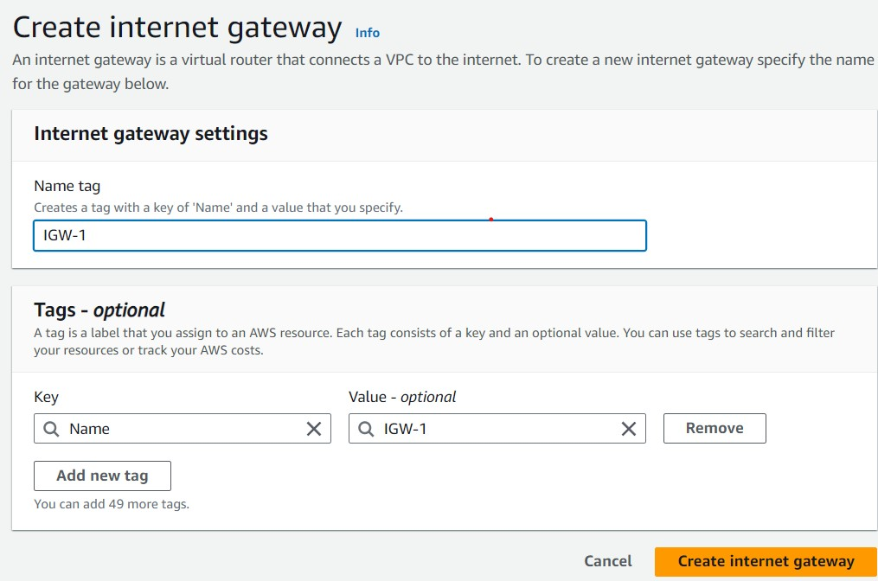

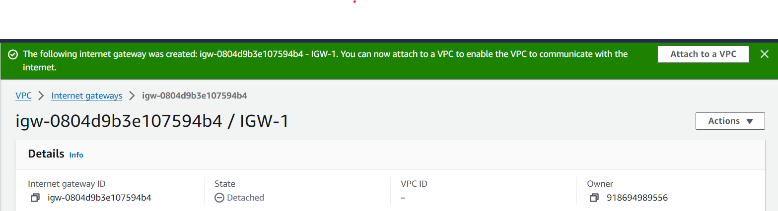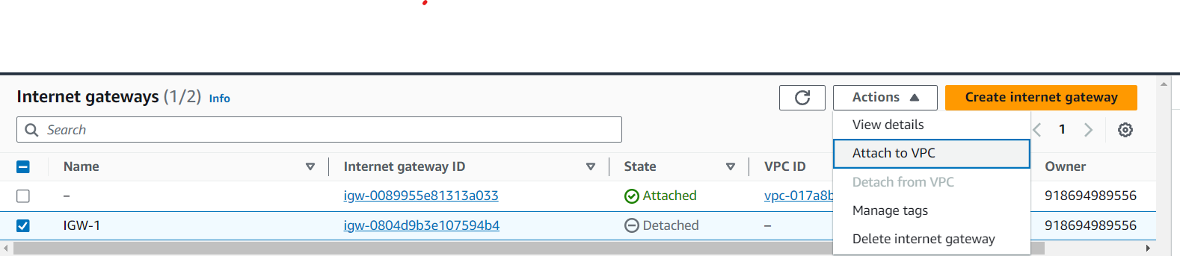

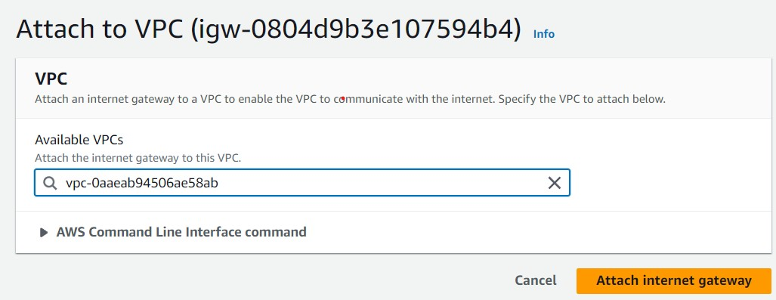

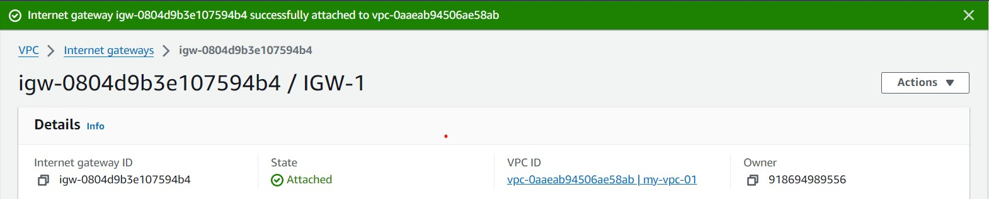

CREATE NAT GATEWAY NAME: NGW-1

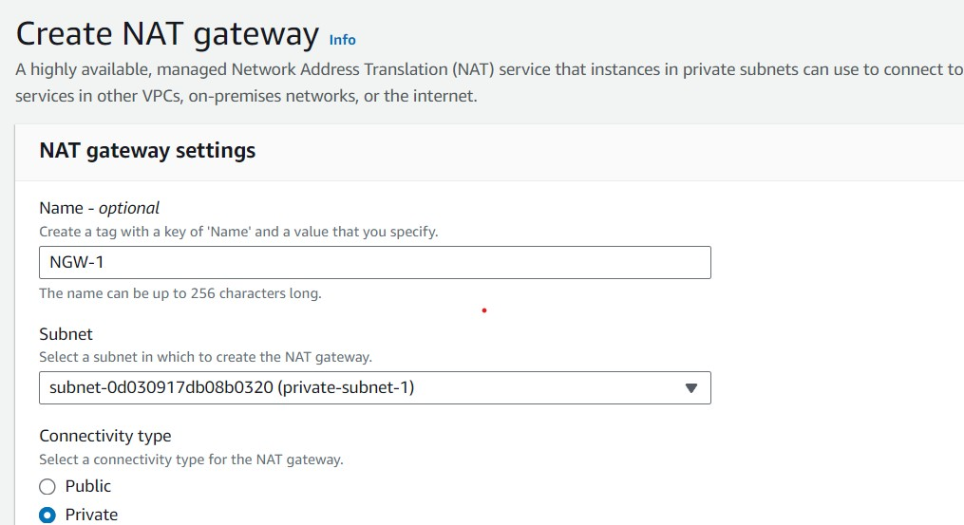

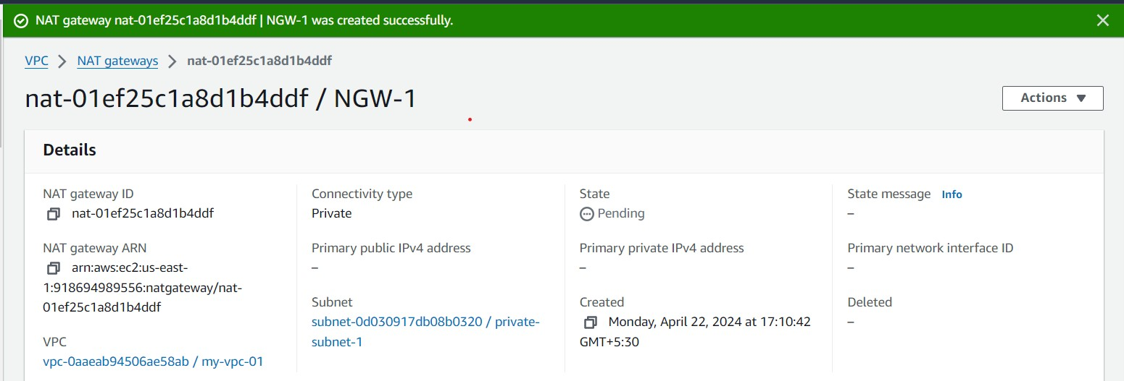

CREATE ROUTE TABLE: 01

NAME: public-route

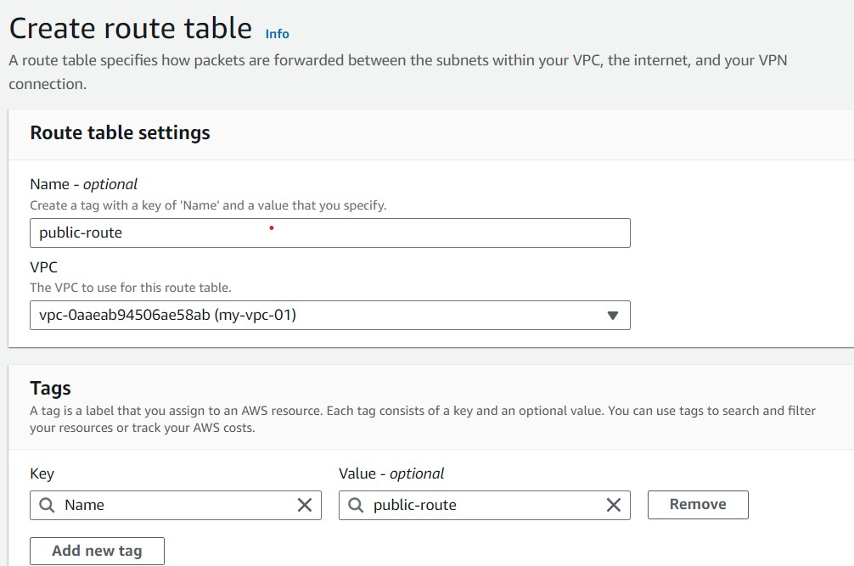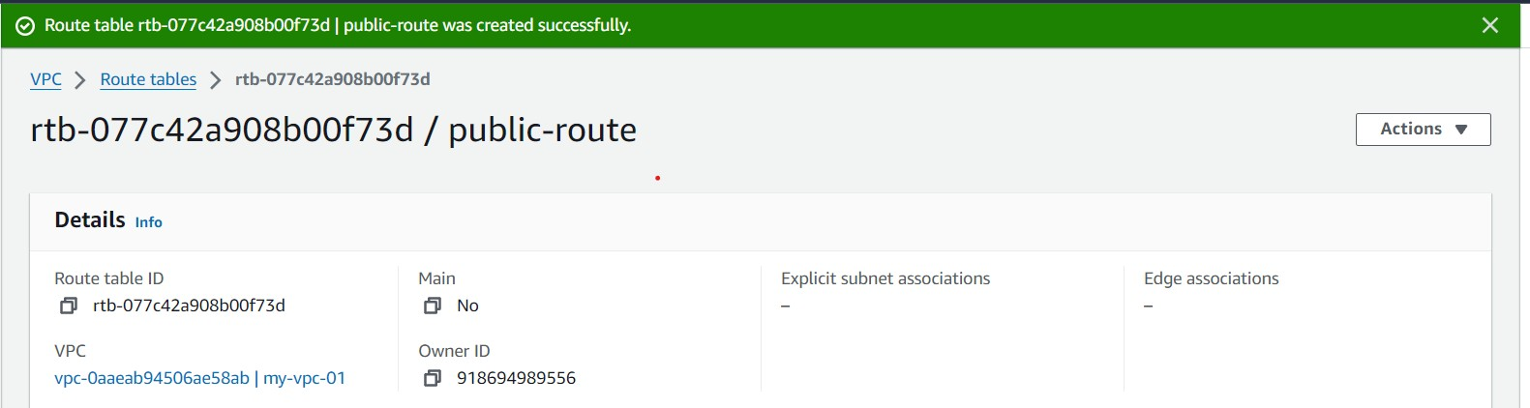

Here I edit the public route and attach internet gateway

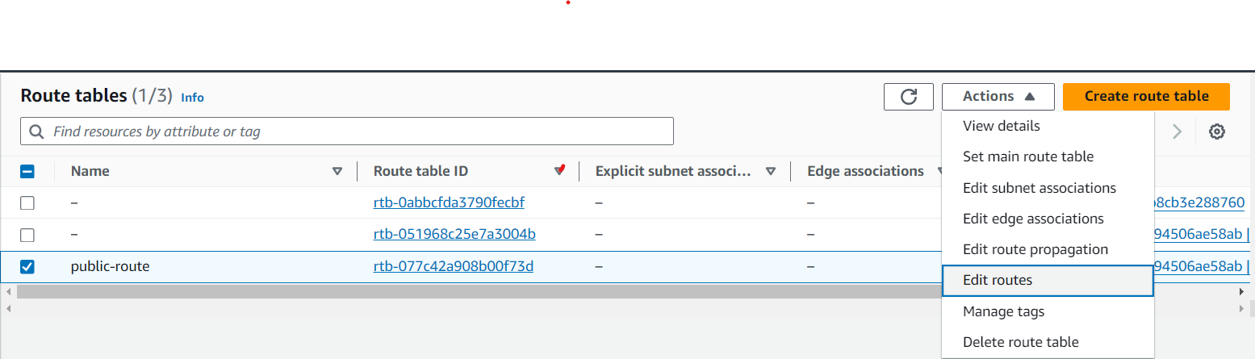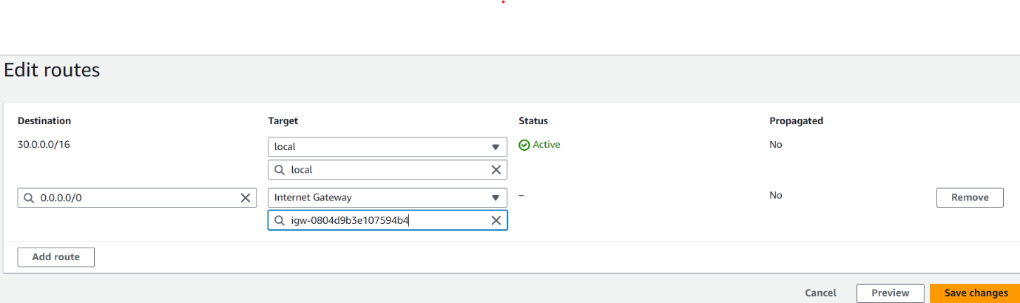

EDIT THE SUBNET ASSOCIATIONS AND ATTACH THE TWO PUBLIC SUBNETS TO PUBLIC ROUTE TABLE

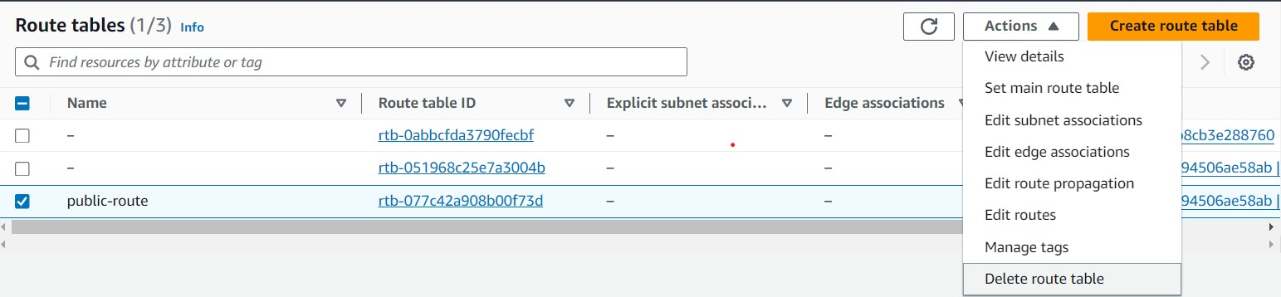

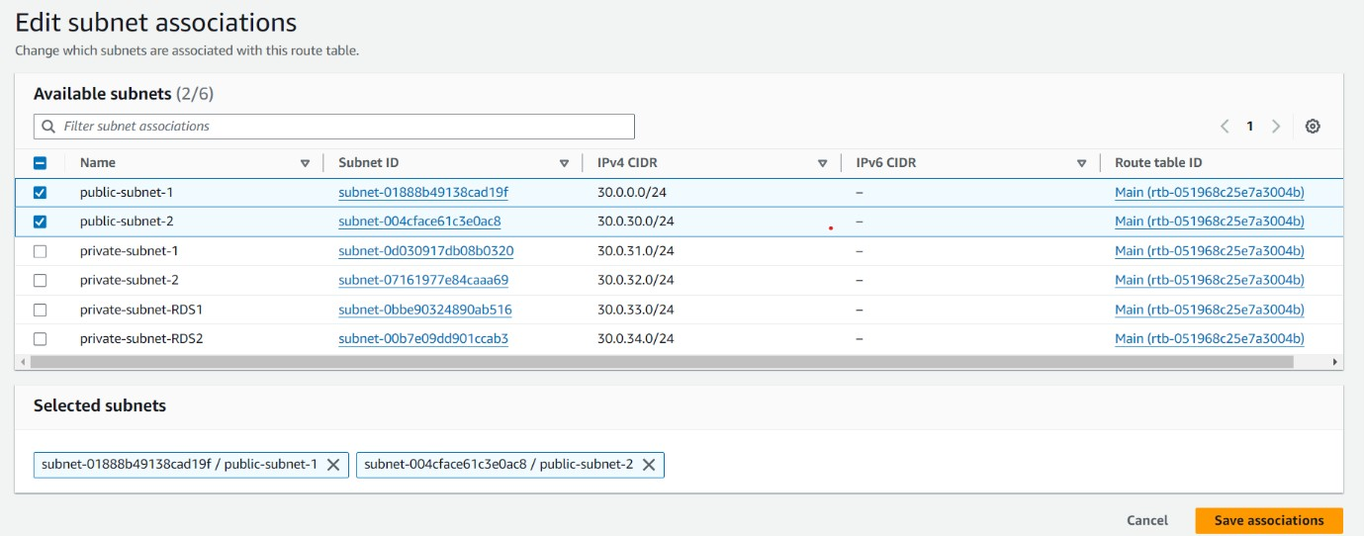

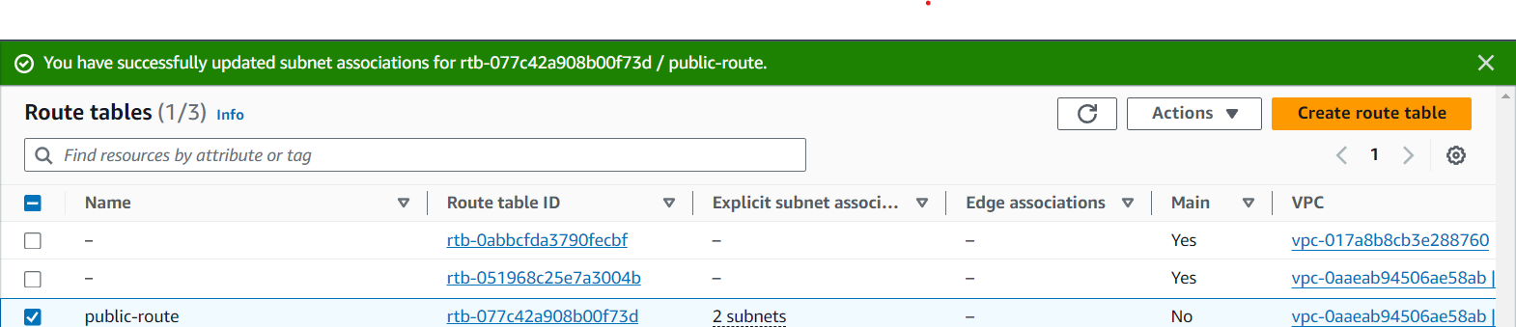

NOW CREATE THE PRIVATE ROUTE TABLE:

NAME: private-route

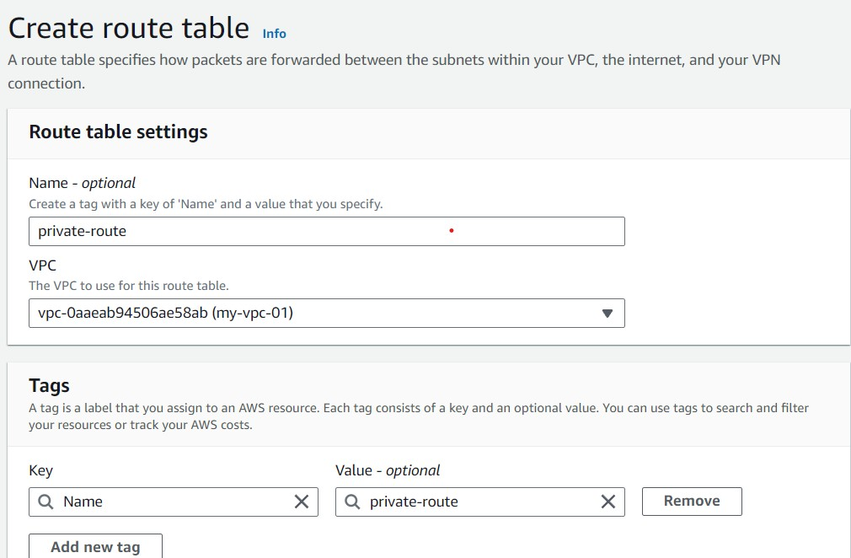

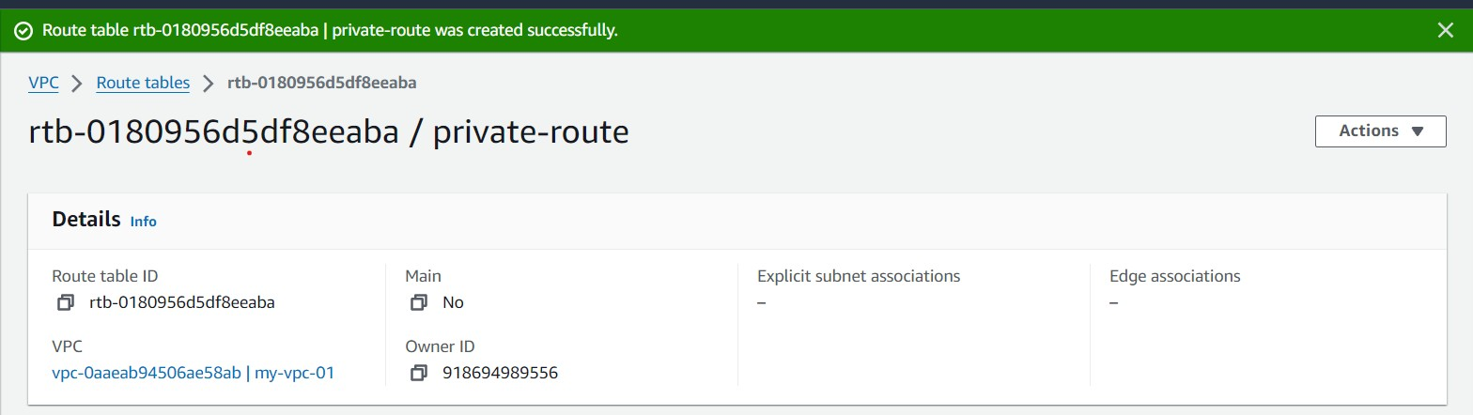

HERE I EDIT SUBNET ASSOCIATION AND ATTACH FOUR PRIVATE SUBNETS TO THE PRIVATE ROUTE TABLE

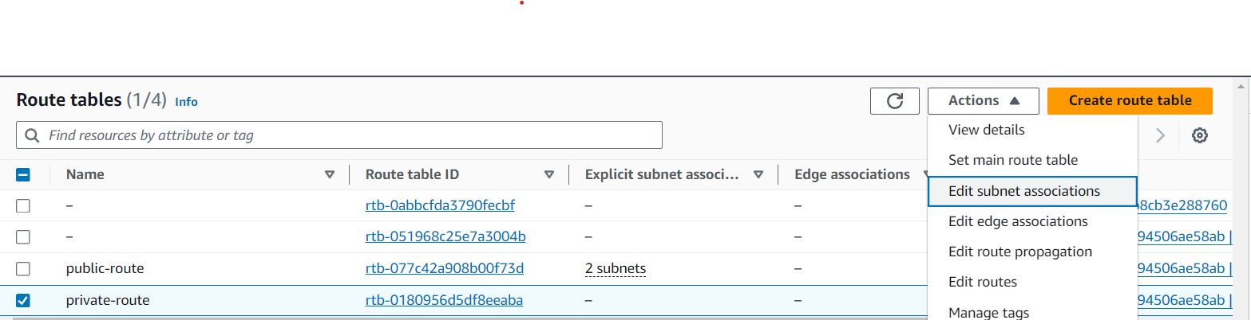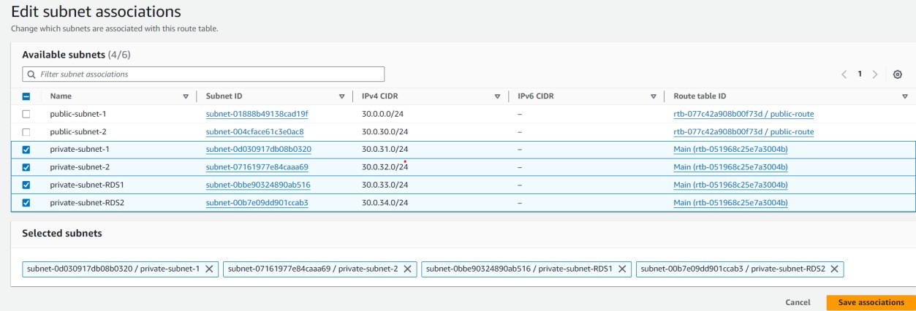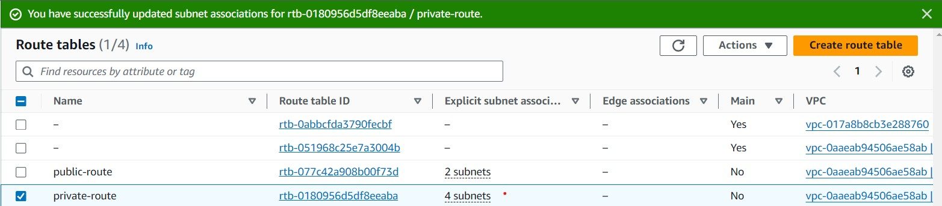

NOW EDIT THE PRIVATE ROUTE TABLE AND ATTACH NAT GATEWAY

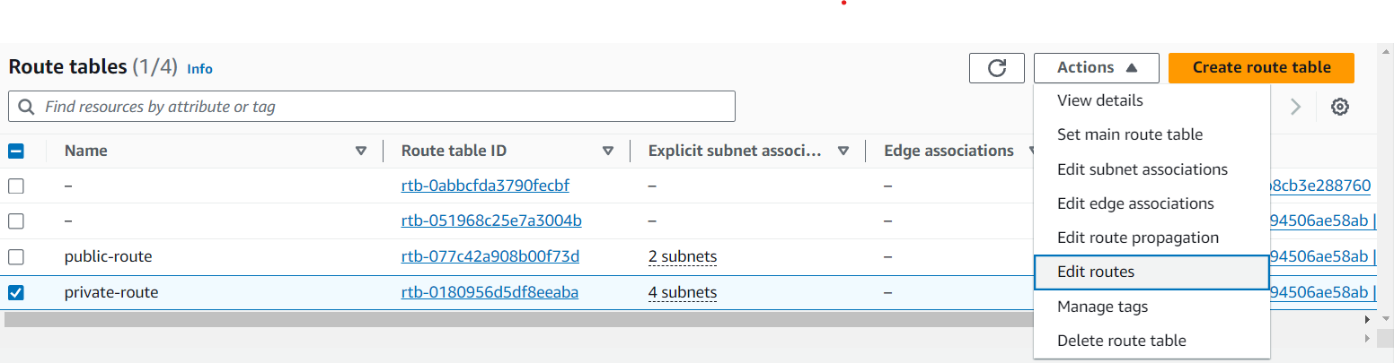

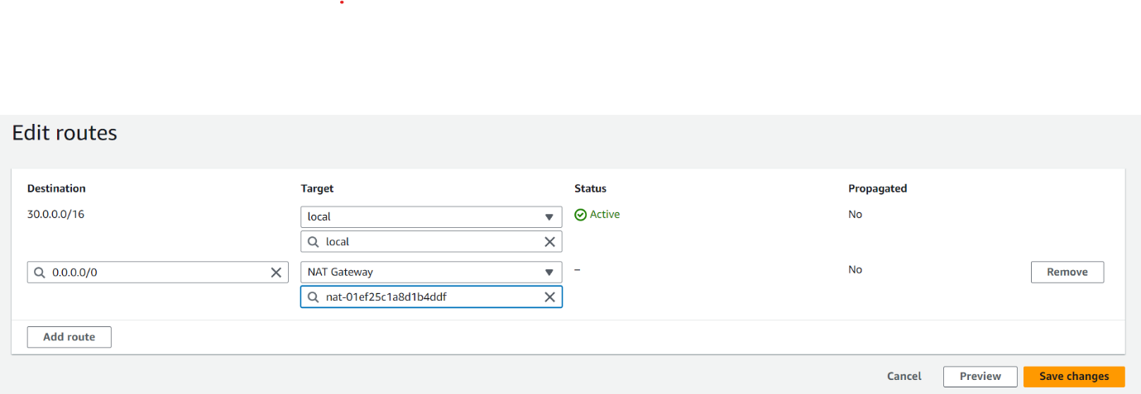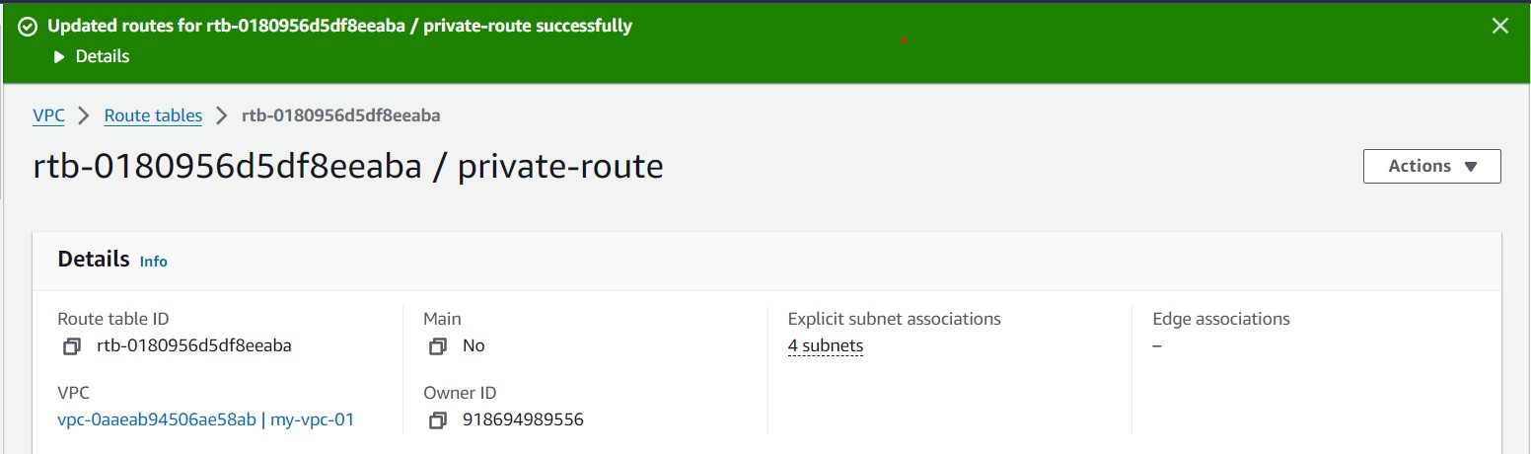

HERE I GO TO ACTION AND EDIT SUBNET SETTINGS TO ENABLE AUTO ASSIGN PUBLIC IPV4 ADDRESS

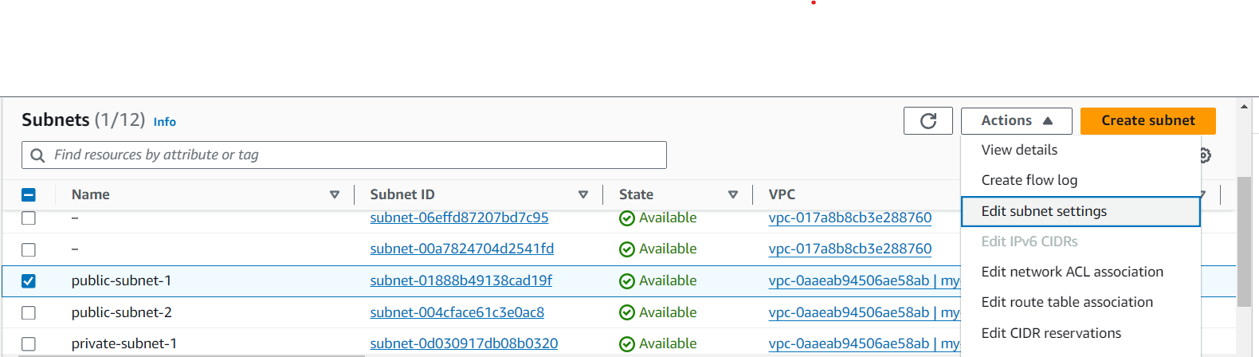

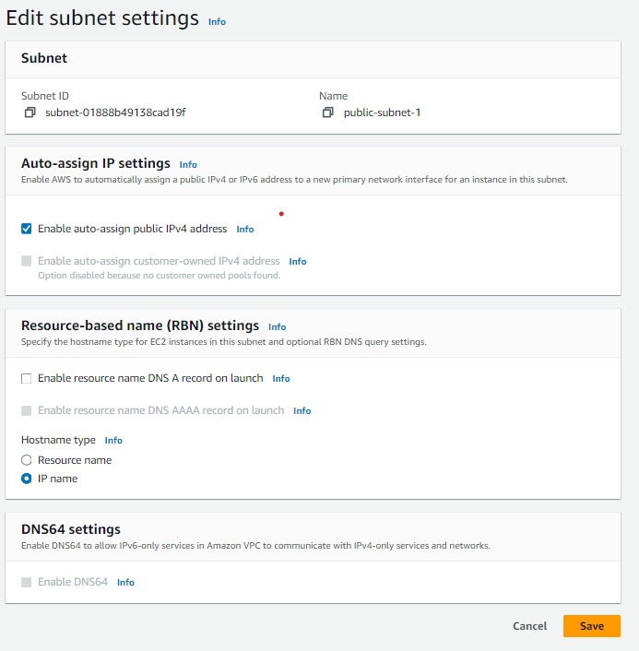



NOTE: HERE SAME PROCESS TO REMAINING FIVE SUBNETS

CREATS SECURITY GROUPS: 02

FIRST SECURITY GROUP NAME: security-group11

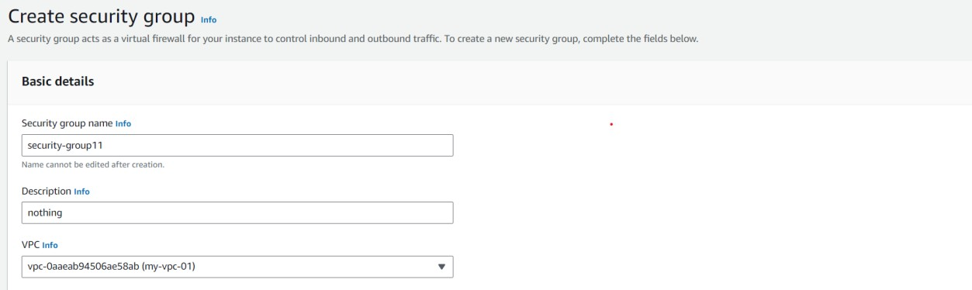

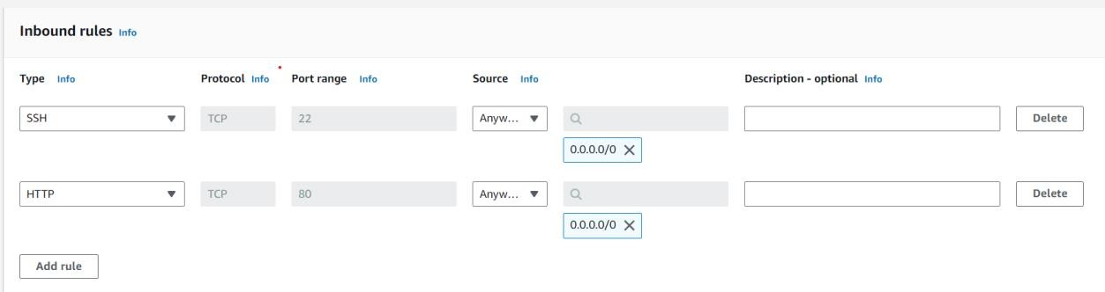

SECOND SECURITY GROUP NAME: security-group22

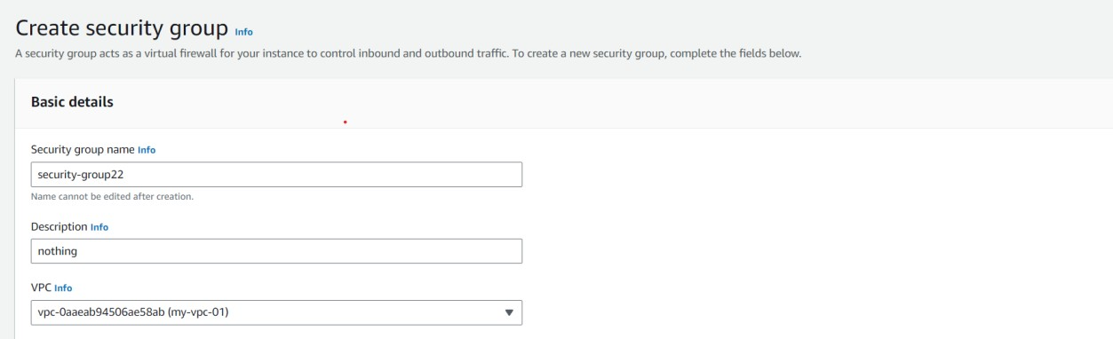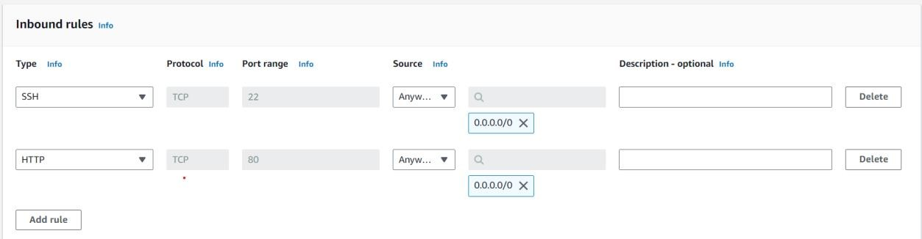



NOW LAUNCH TWO TEMPLATES:

FIRST TEMPLATE NAME: public-template

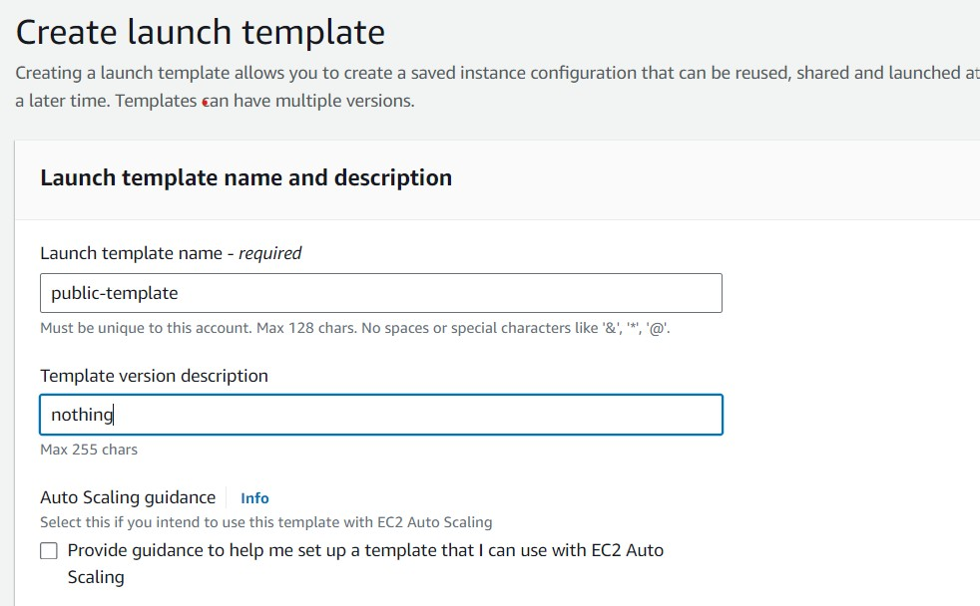

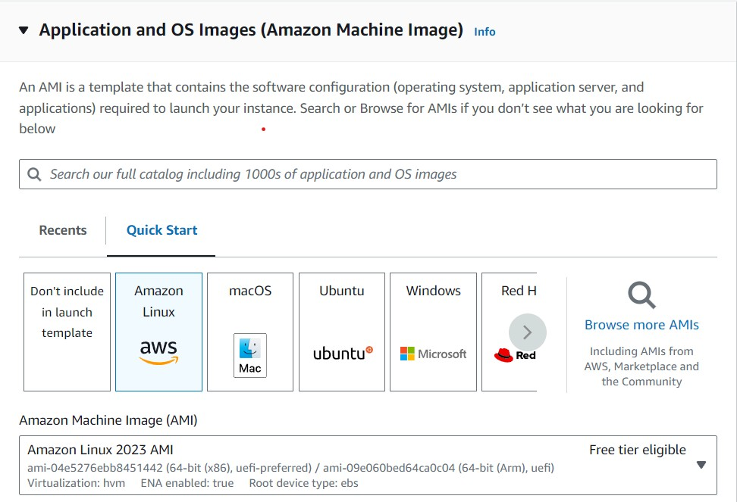

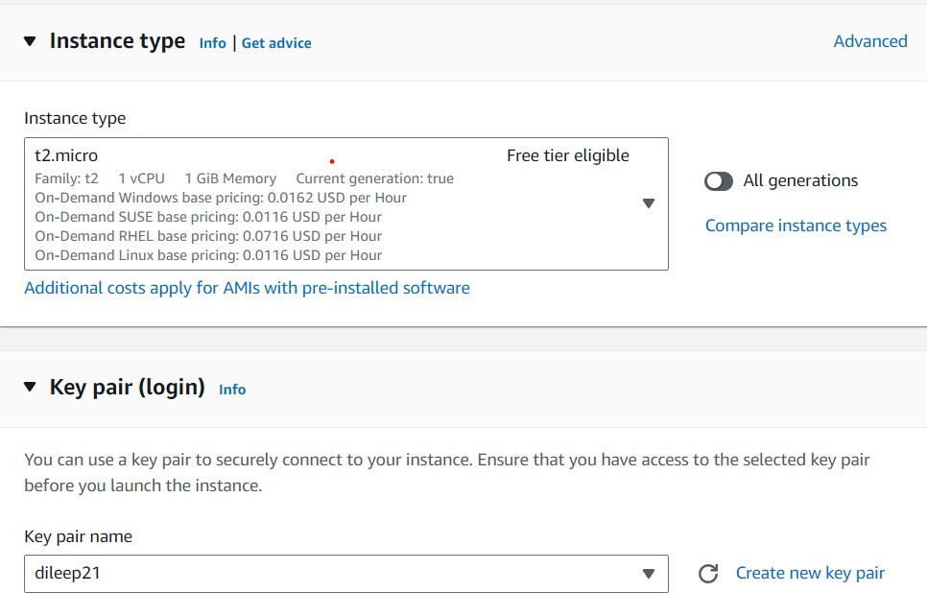

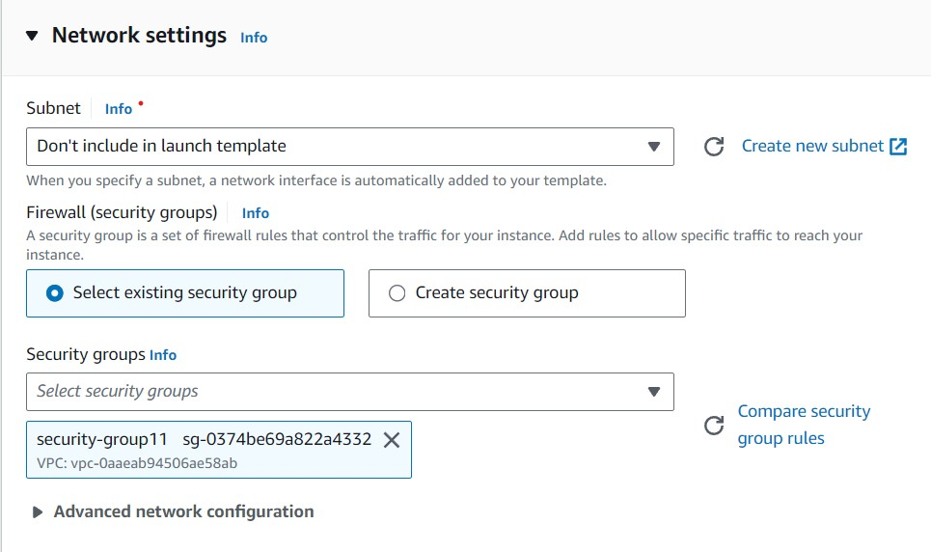



SECOND TEMPLATE NAME: private-template

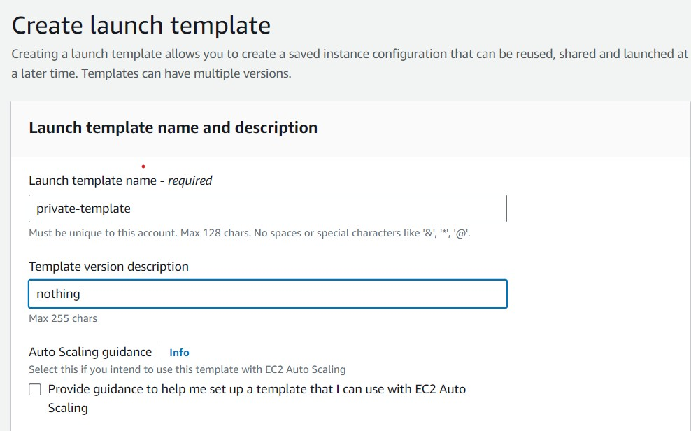

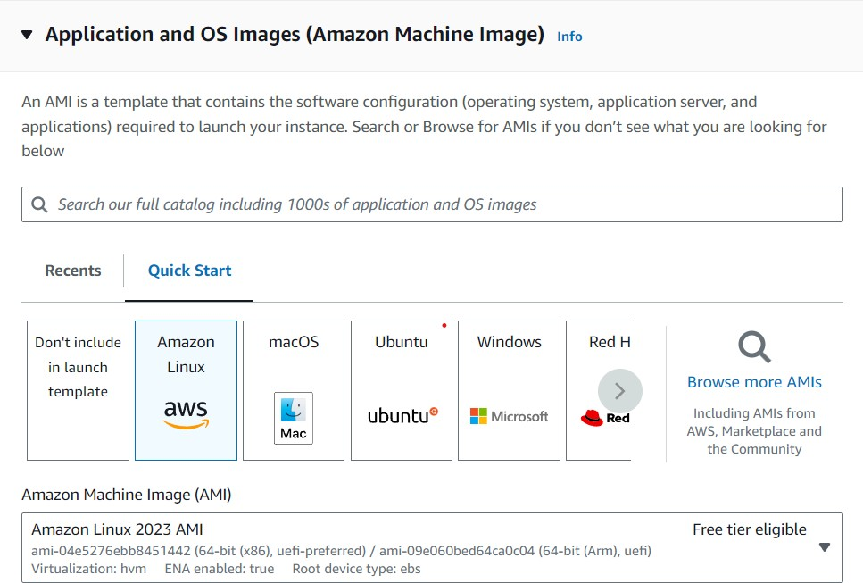

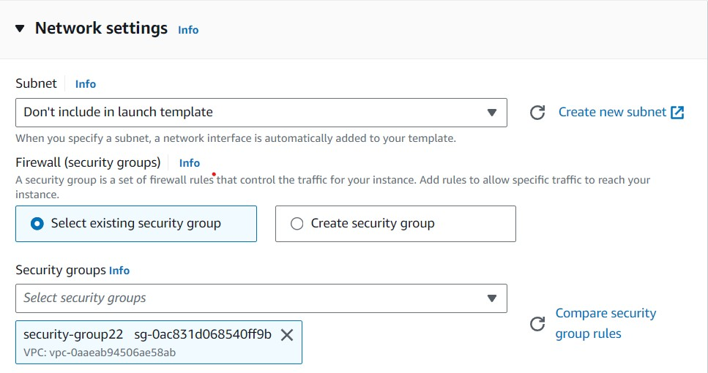

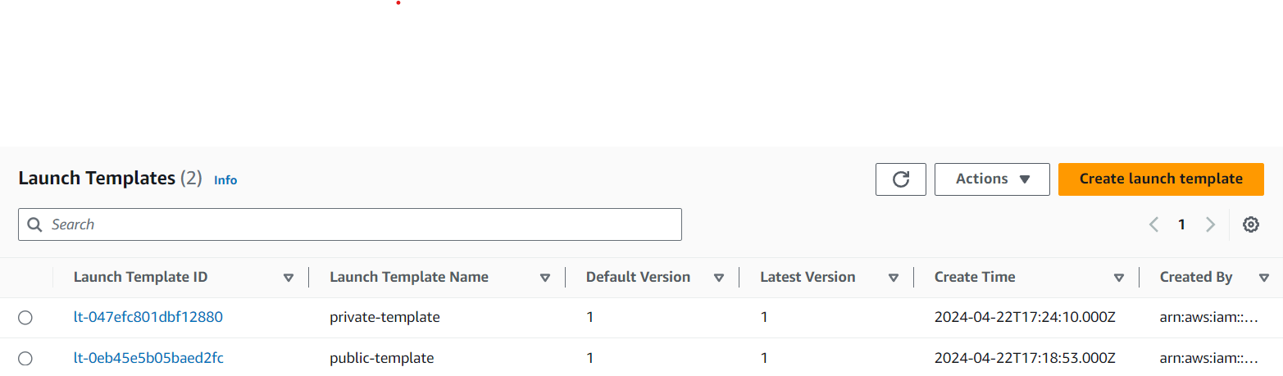

LAUNCH AUTO SCALINGS GROUPS TWO:

FIRST AUTO SCALING GROUP NAME: auto-scaling-public

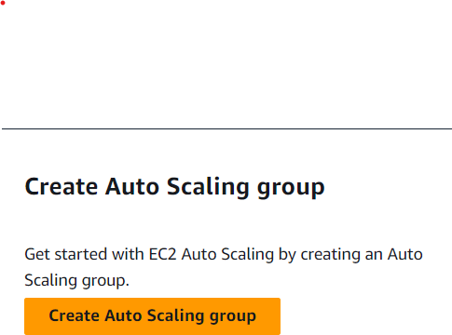

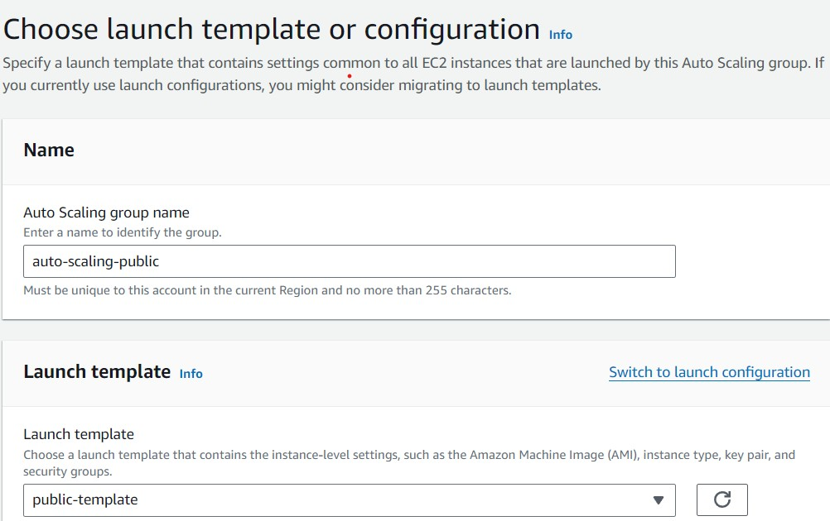

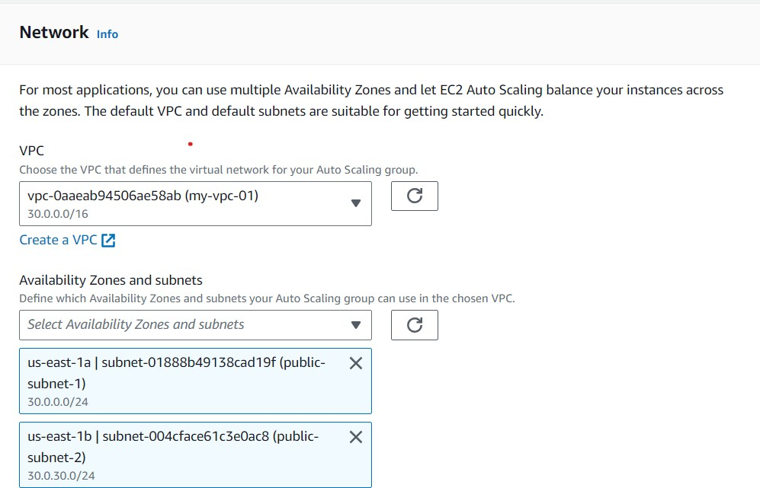

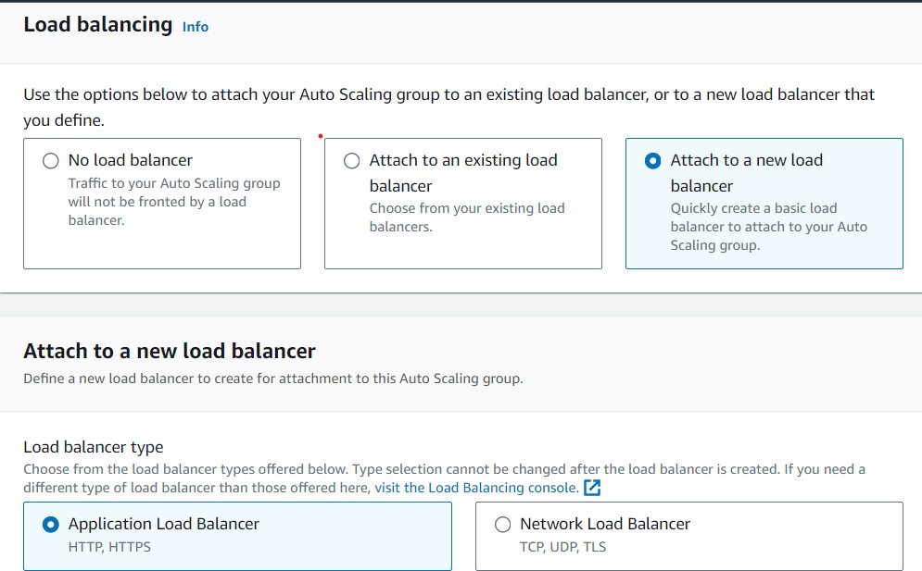

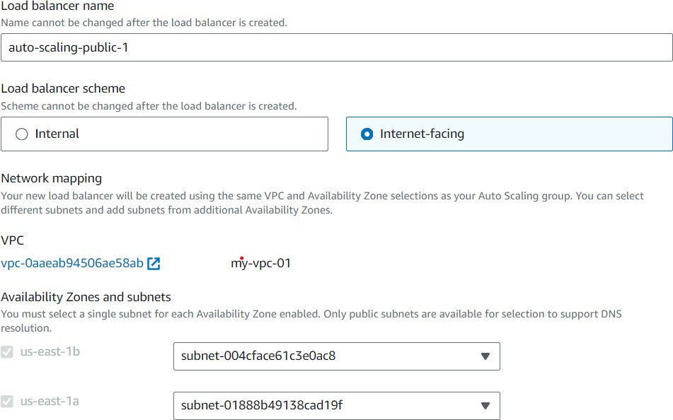

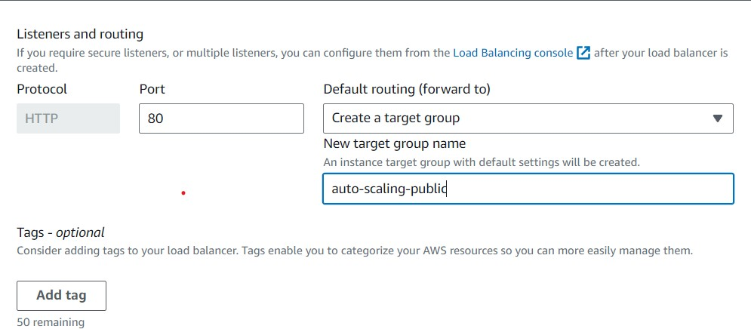

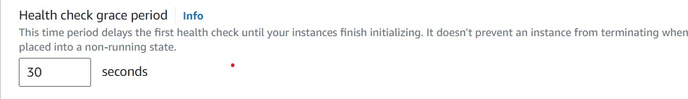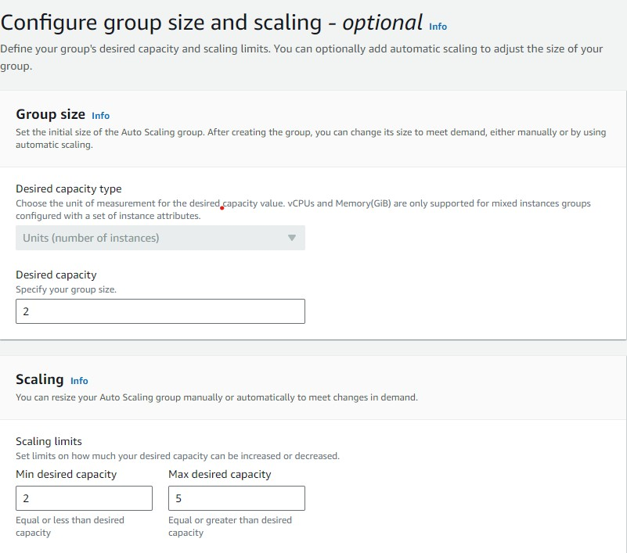

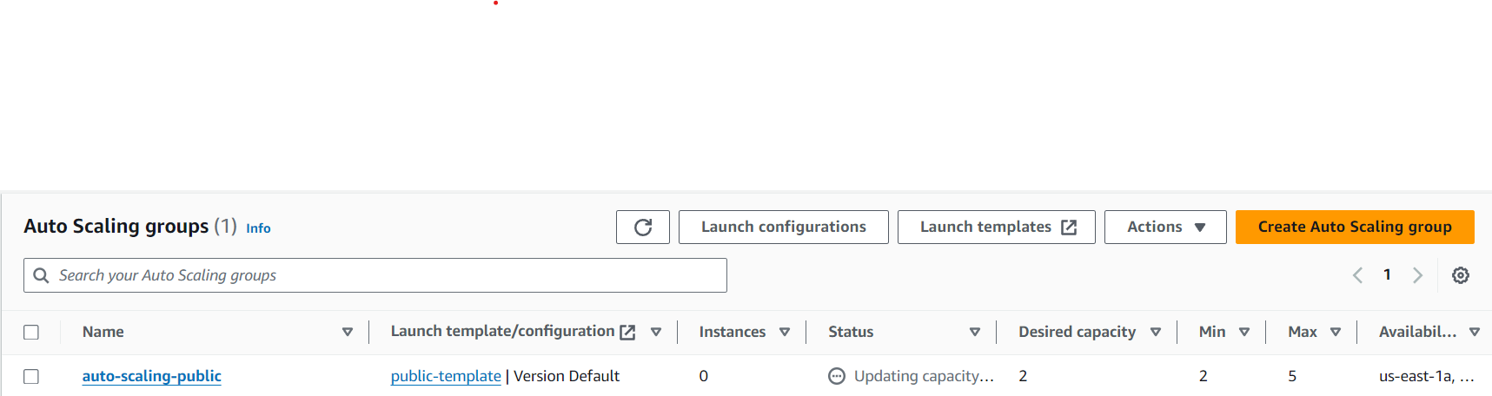

SECOND AUTO SCALING GROUP NAME: auto-scaling-private

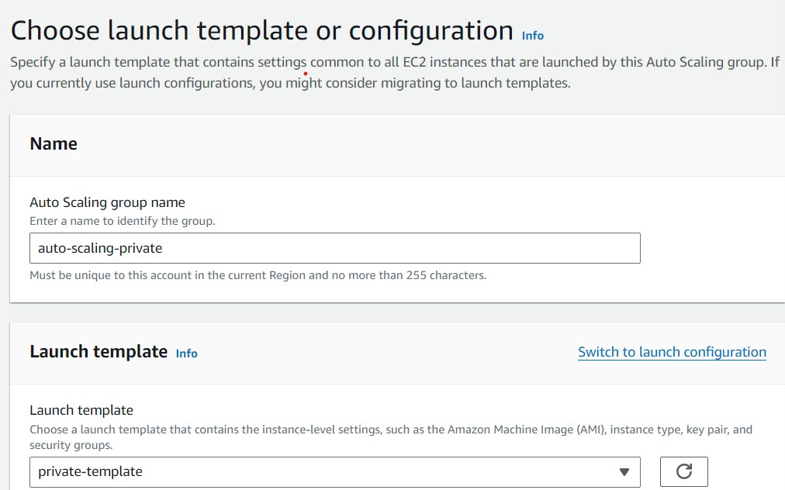

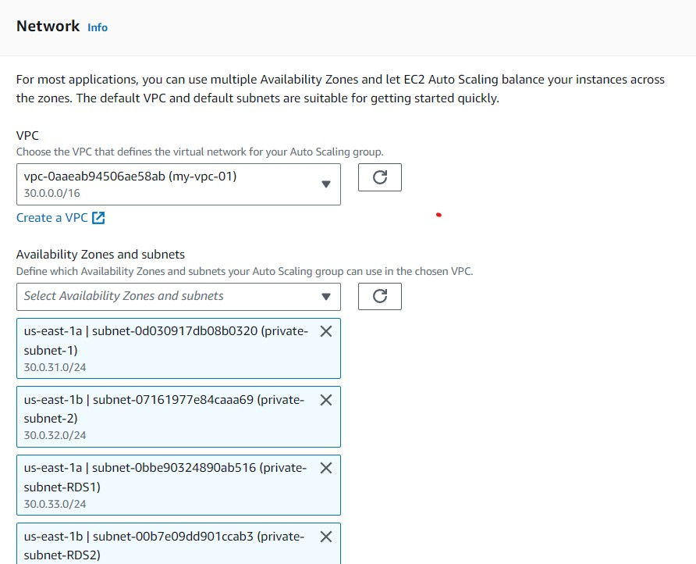

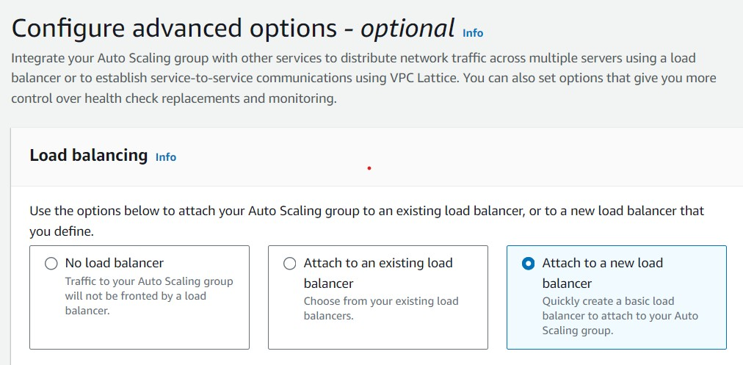

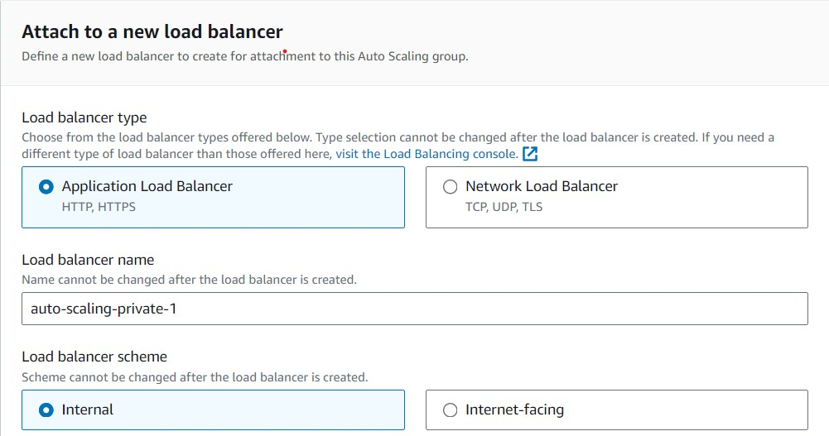

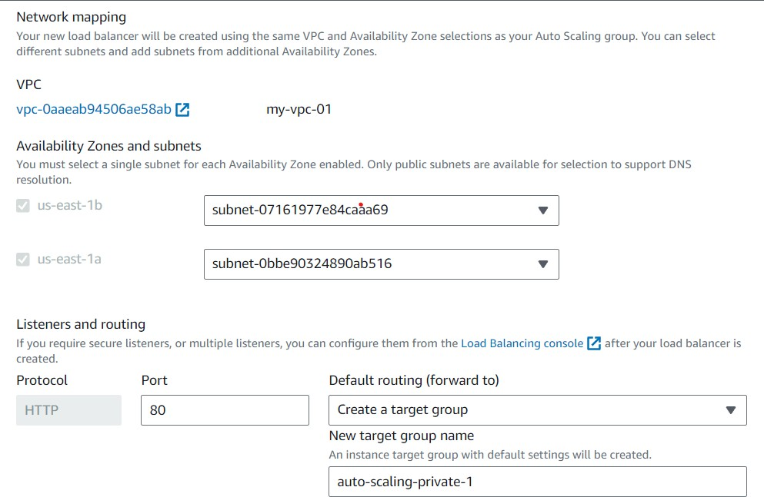

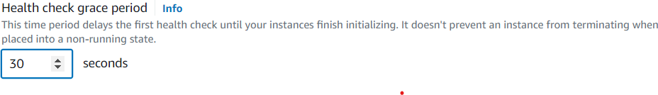

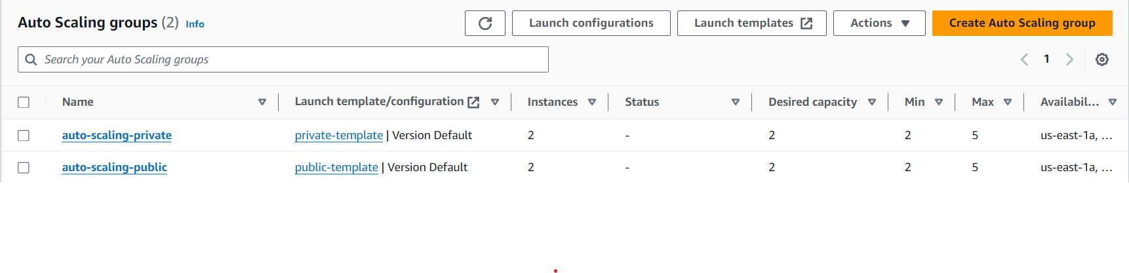

CREATED AUTOMATICALLY EC2 INSTANCES

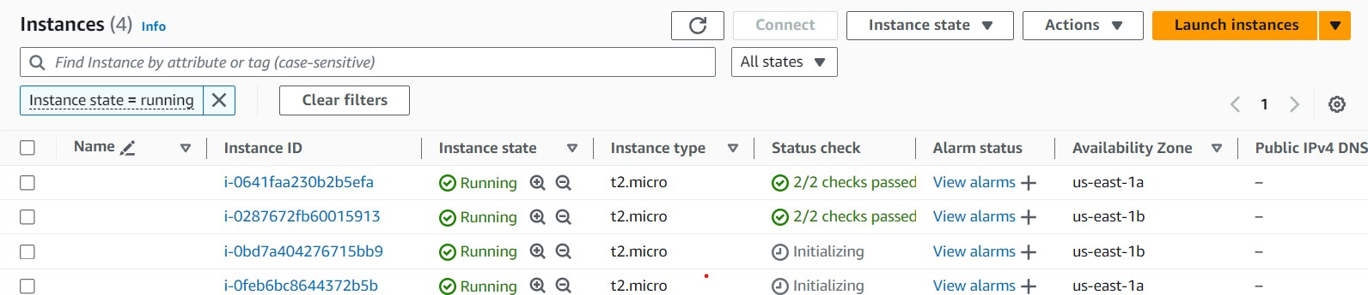

GIVE THE NAMES TO THE EC2 INSTANCES:

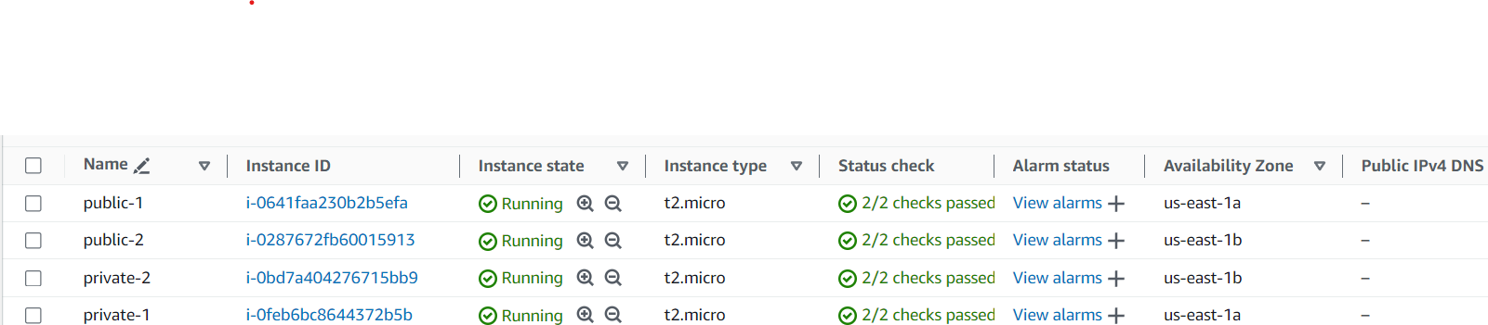

PUBLIC1 INSTANCE CONNECT TO THE WEB:

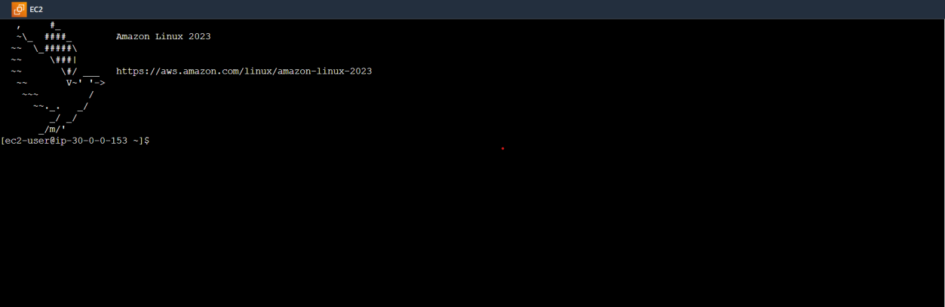

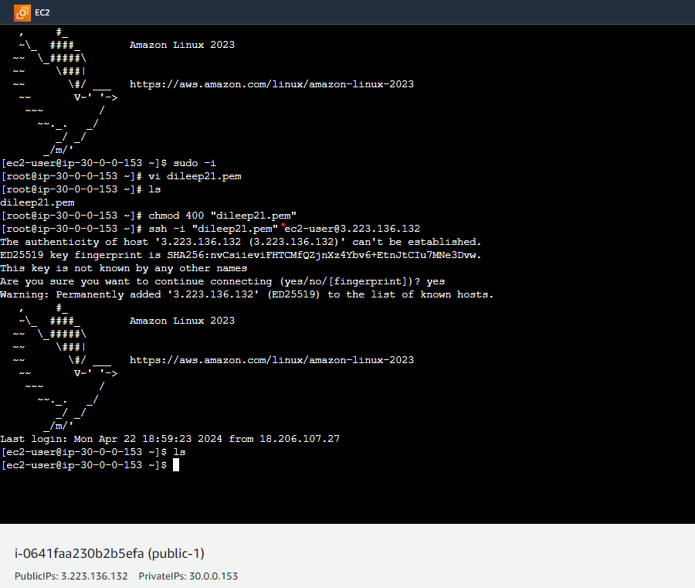

PUBLIC1 INSTANCE ATTACHED TO PRIVATE1 INSTANCE

NOW PUBLIC2 INSTANCE ATTACHED TO THE WEB:



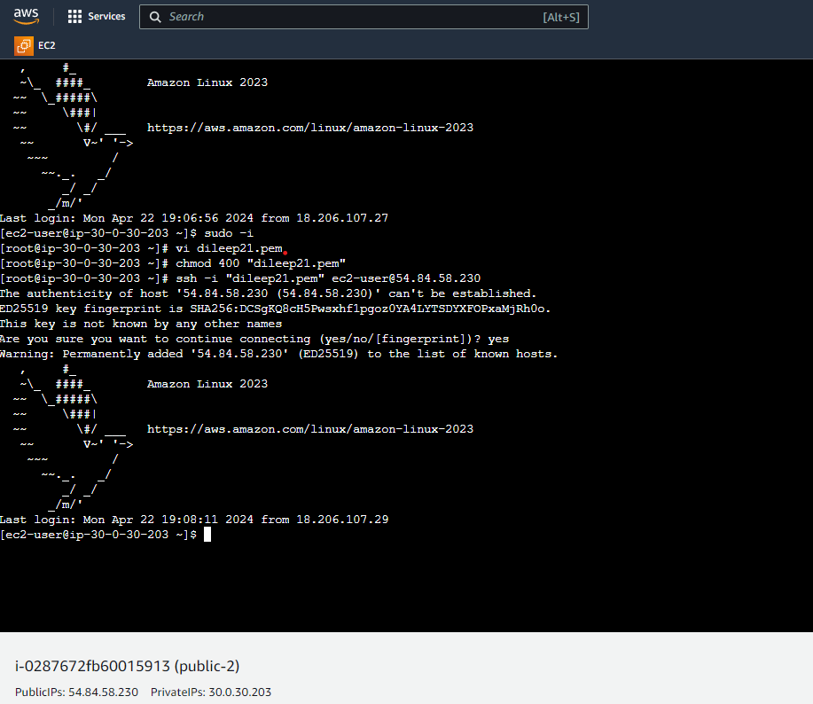

PUBLIC2 INSTANCE ATTACH TO PRIVATE2 INSTANCE

CREATE DATABASE:

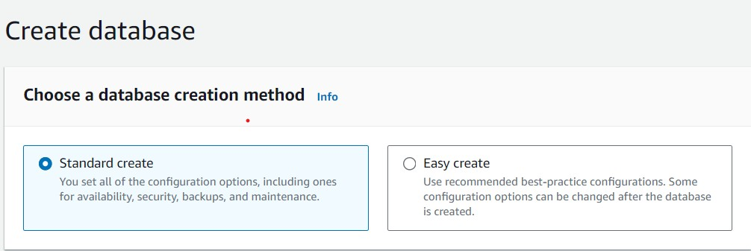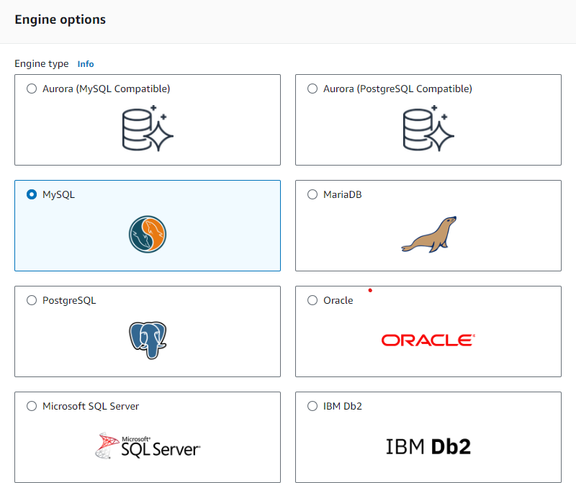

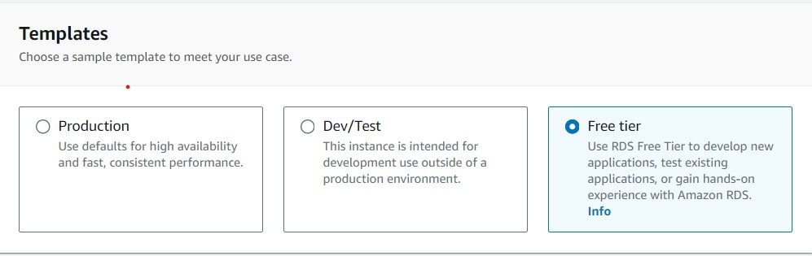

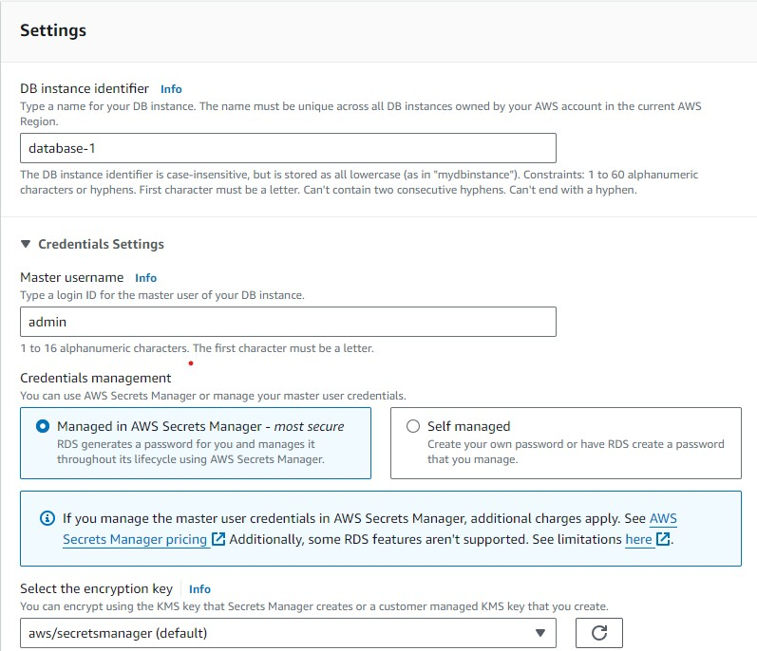

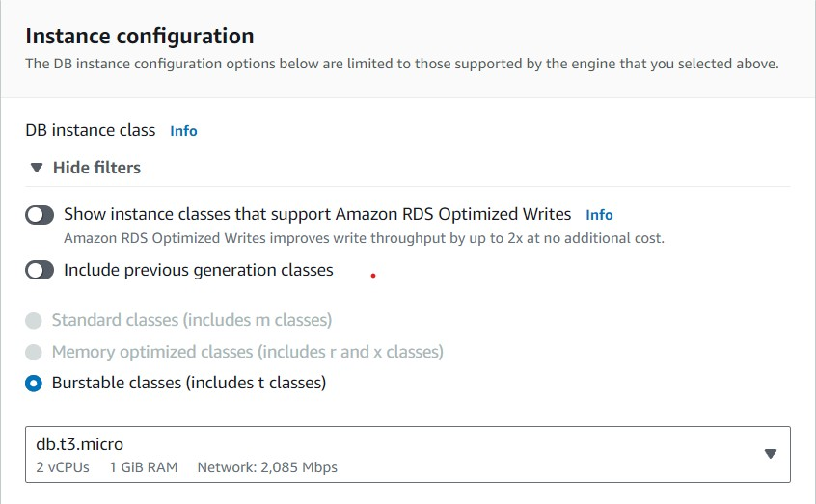

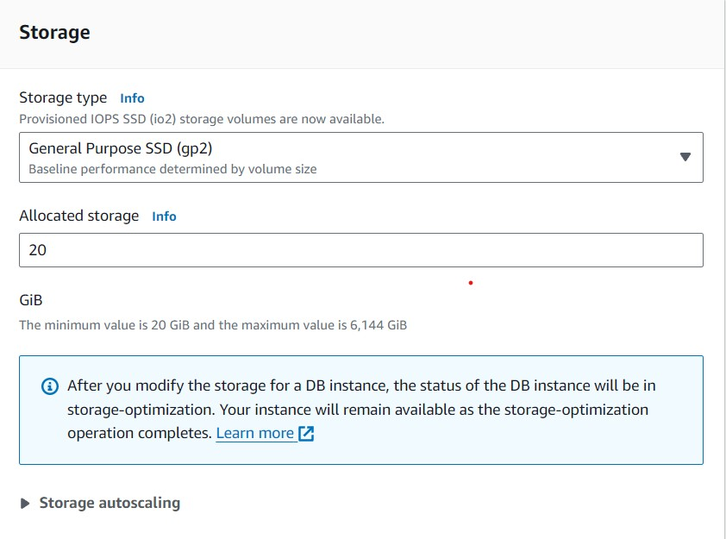

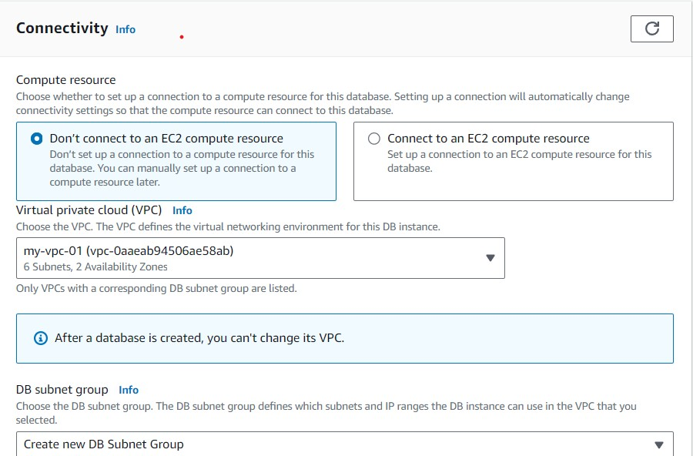

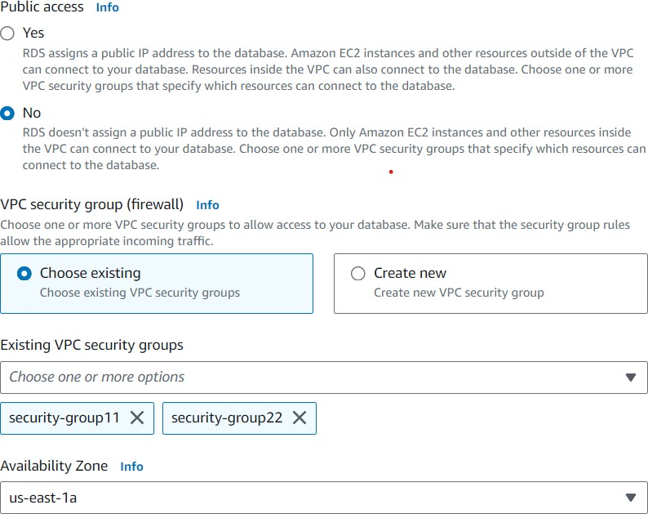

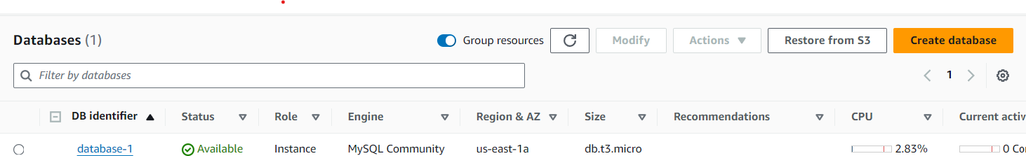

CREATE DB SUBNET GROUP:

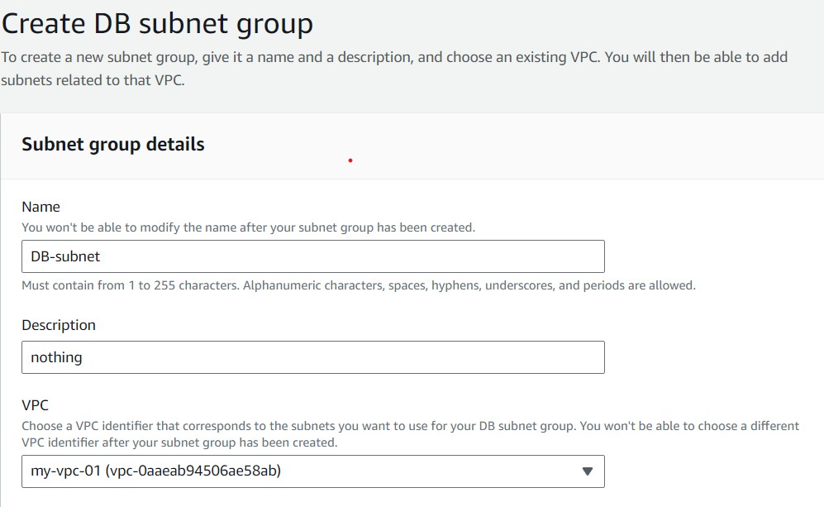

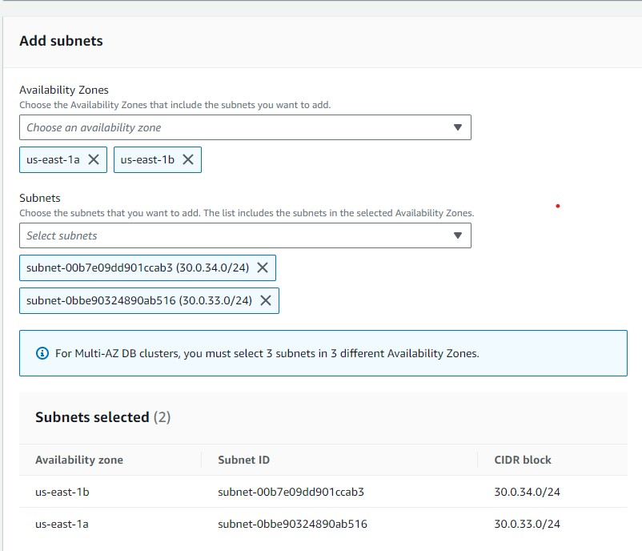

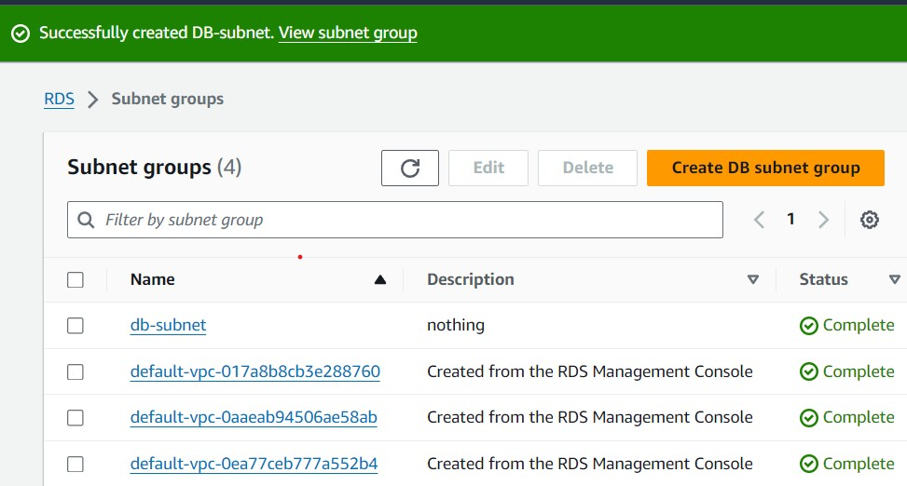

CREATE DB SNAPSHOT:

